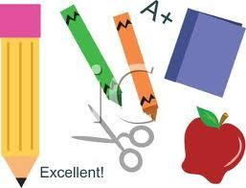

**St. John Paul II**

**Kindergarten Supplies 2024-2025**

Items that will be shared with the class and do NOT need your child’s name on them:

* 3 boxes of Crayola Reg. Crayons (8 pack)
* 1pkg. thin black Expo markers
* 1 sock (will be used as a white board eraser)
* 6 jumbo glue sticks
* 2 rolls of paper towels
* 2 containers of Clorox wipes or baby wipes
* 2 boxes of Kleenex
* Girls - 1 box of gallon Ziploc bags
* Boys - 1 box of quart sized Ziploc bags
* Girls - 1 box of Laddie Pencils
* Boys - 1 box of regular size pencils
* 1 pair of Fiskars scissors
* 1 pkg. of white cardstock
* 2 10” Composition Notebooks Wide Ruled
* 1 beach towel for rest time (size of your child’s body)
* 1 pair of over-the-ear headphones (no earbuds)